Purpose
When tissue is submitted for controls, one H&E slide is made from each block. A machine punches samples of the tissue from each block, 12 punches per block. On each control block there are 12 punches of tissue as follows:
Tonsil | Colon | Skin | Prostate | Kidney | Placenta
Tonsil | Colon | Stomach | Liver | Thyroid | Brain
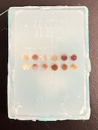

- Control tissue cannot be in formalin for over 1 month.
- Tissue cannot touch the edges of the cassette.
- Do no submit tissue that is calcified or too hard.

Procedure
- Any color cassette can be used.
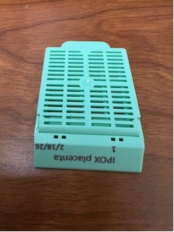
- Label the block with “IPOX”, tissue type, a number, and the date the blocks are being submitted.
- An H&E slide is made from each block. The number on the blocks corresponds to the slide number.
- Printing numbers on cassettes eliminates extra work for IPOX when they embed the tissue.
- See directions below on how to print control blocks.

Tisue for Submission

- Tonsil
- Request from Mott and BCSC ORs. Send e-mail to lead PA about the need for tonsil tissue. The lead PA will contact the nurse staff at Mott and BCSC.
- Lymph nodules, tonsillar crypt
- Serially sectioned, 1 piece per cassette
- Colon
  - Mucosa and submucosa
  - Normal colon, no IBD or IBS
  - 1 full thickness section running length of the block OR 2 full thickness sections
  - 4-5 mm thick
- Skin
- Epidermis and dermis
  - Full thickness epidermis and dermis with no subcutaneous fat
  - Areas with potential of sun exposure
  - Minimal hair
  - 1 or 2 pieces, running the length of the cassette
- Stomach
- Mucosa
  - Normal
  - 1 or 2 pieces running the length of the cassette (no more than two pieces)
- Prostate
  - Acini glands
- 1 piece per block
- Retained section from whole mounts or cystoprostatectomies
- Placenta
  - Trophoblasts
  - 1 full thickness section per block
- Kidney
- Renal cortex only
- 1 piece per block
- Thyroid
- Follicles
- Benign thyroid parenchyma
- 1 piece per cassette
- Brain
- Morgue. Email PA in the morgue to collect brain tissue to be sent to NCRC.
- Postmortem interval less than 24 hours
- Cerebrum, Grey-white matter junction
- 1 piece per cassette

How to print control cassettes with Flex Printer

- Accession No* field: Include IPOX and tissue type
  - Example: IPOX thyroid
- Block field: Number of first cassette (block number starting with)
- Quantity: Number of sequential blocks to print
  - If you want to print 15 blocks, type 15 in the Quantity field and it will print sequential numbers beginning with the number entered in the Block field.
- Other: Type in the date that the blocks are being submitted.
- Click on a cassette color to print cassettes.

